Instruction For TCP Server Simulator – Australia SCG Loco

Abstract

This Instruction brings how to use the TCP Server Simulator for the Project Australia SCG Loco.

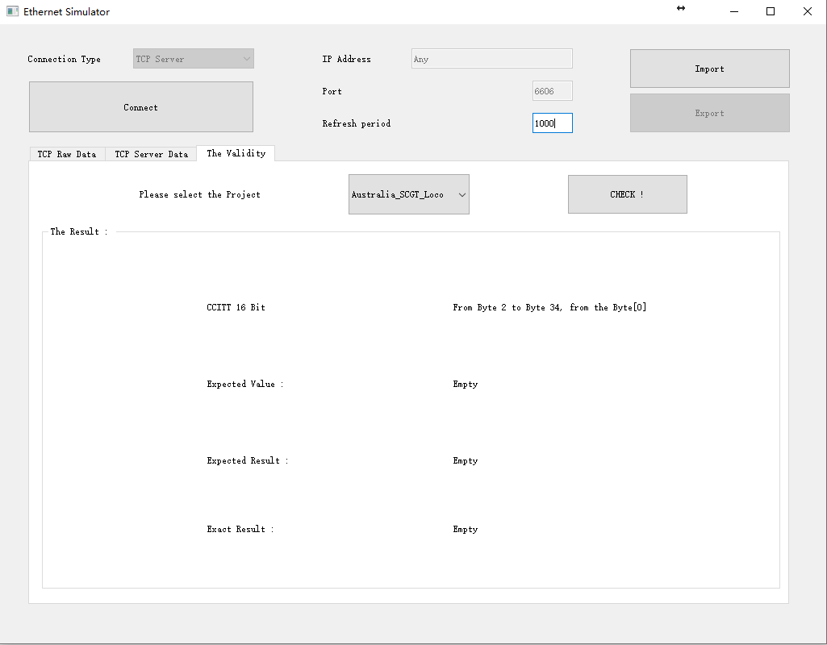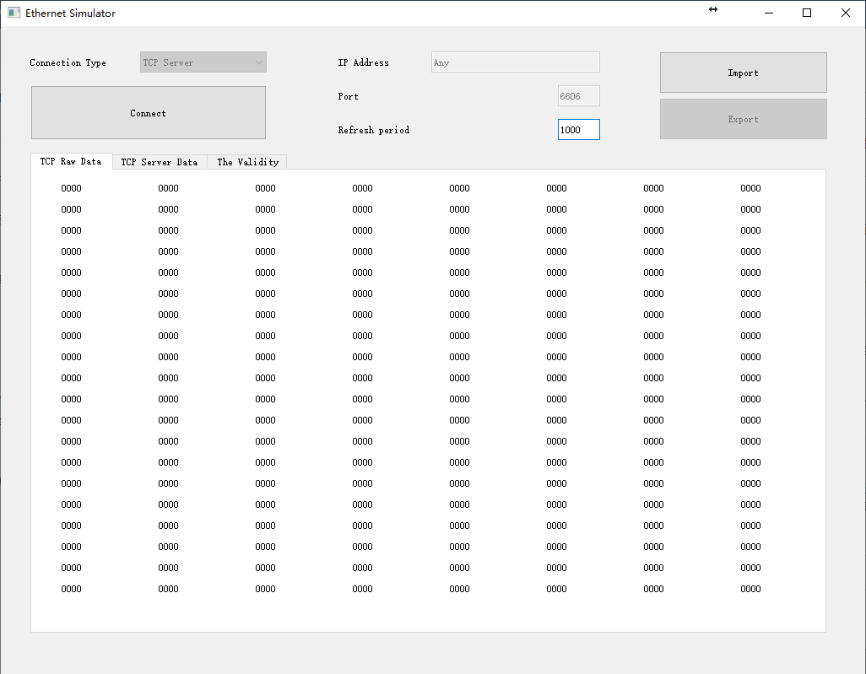Version History

| Revision | Issues / changes | creator | Date |
| --- | --- | --- | --- |
| A00 | First Creation | Vincent Zhao | 12.11.2020 |
|  |  |  |  |
|  |  |  |  |
|  |  |  |  |
|  |  |  |  |

Table of Contents

1 To have the Simulator 5

1.1 How to Install/Compile 5

1.2 Linux File List 5

1.3 Windows File List 5

2 What the Simulator can do 6

2.1 Raw data Mode 6

2.1.1 To Connect 6

2.1.2 The Validity 7

2.2 Data type specified Mode 8

2.2.1 How to Import 8

2.2.2 Supported File Type 8

2.2.3 Rule 8

2.2.4 File example 9

3 Incoming Features 10

# To have the Simulator

## How to Install/Compile

For the Linux, please run “apt-get install qt5”, or similar packages, but please make sure to install the Qt version 5.X. And yes, to the <http://download.qt.io/archive/qt/> to download is also a choice.

To support C++11, the GCC version need to be bigger/newer than 4.6.4, which is normally supported now.

With Qt5 and C++11 supported, input command “qmake” in the root folder of the “EthernetSimulator”, to have the Makefile, then “make”. With a successful compliation, it shall have the executable file named “EthernetSimulator”.

For the Windows, run the install file “EthernetSimulatorInstall.exe”, and after successful installation, Windows shall have the “EthernetSimulator.exe” then.

Then, just simply run it.

## Linux File List

EthernetSimulator.pro, hpcsvoperator.h.cpp, hpimportexportobject.h.cpp

hpmainwidget.h.cpp hpnetworkdatamodel.h.cpp hpmaincontroller.h.cpp

hpnetworksocket.h.cpp hpxmloperator.h.cpp main.cpp

## Windows File List

EthernetSimulatorInstaller.exe

# What the Simulator can do

## Raw data Mode

The simulator has the basic functionality to display raw data from the connected TCP Socket.

And offers the Validity for the specific projects.

### To Connect

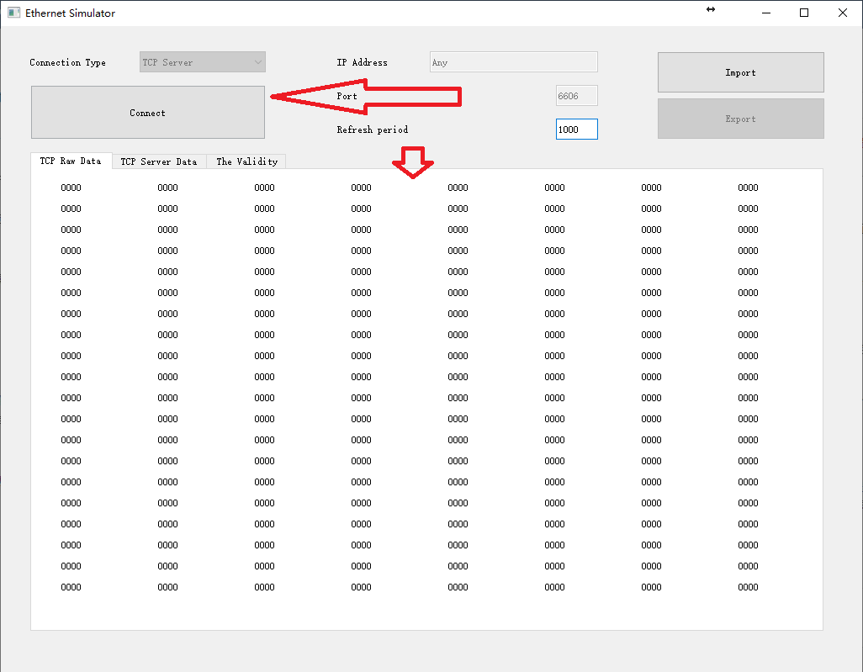

Click the “Connect” button, then the data from connected TCP Socket will be displayed below.

One “0000” means two bytes, Hex based.

Due to only has the Tcp Serve mode and has only one project, the IP Address is set default to the Any, and port is 6606.

The refresh period can be modified, means after how many milliseconds the Simulater will read the data from the connected TCP Socket.

**The Simulator only can display the first connected TCP Socket data.**

### The Validity

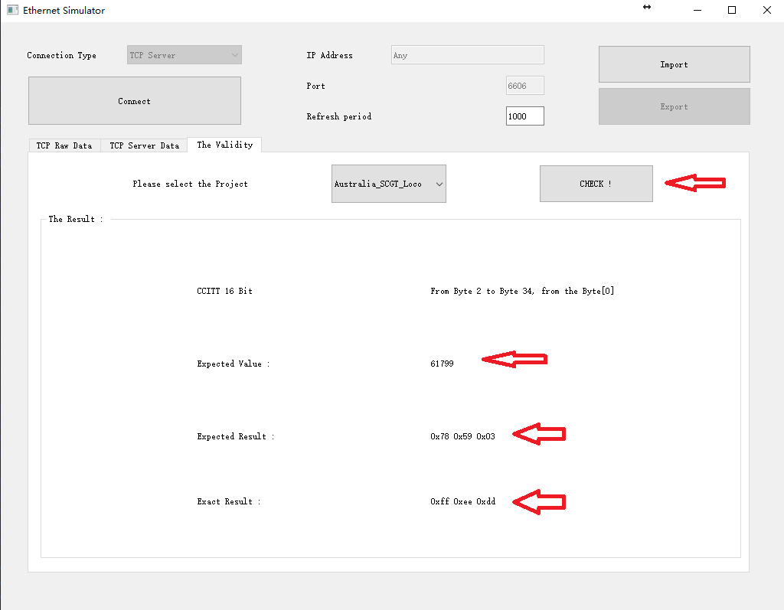

Clicked to check the Validity. The Simulator then will calculate the Validity Number for the specific project, selected in the Combo Box.

The Result will be displayed below.

The first Line, will display the Validity algorithm name, and the Bytes to be checked.

Then, the correct value and the correct corresponding Bytes contents will be displayed, and the exact Bytes contents will be displayed too, for the reference.

## Data type specified Mode

The Simulator can transmit data from raw Bytes to the type specified list, and display them on the UI, for the convenience.

See below the example.

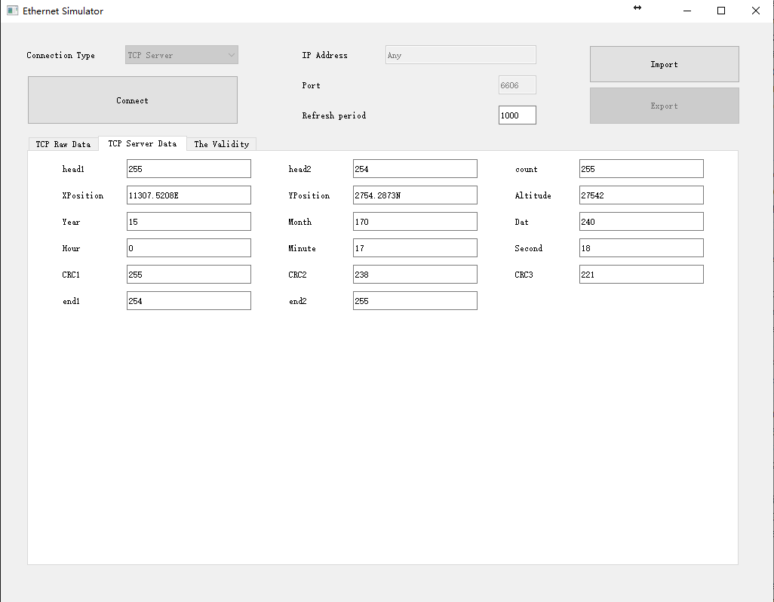

### How to Import

Click the “Import” Button, then select the “*.csv” file which want to import.

### Supported File Type

We only support csv file now, sorry.

### Rule

**Important: It might fail when import file under the folder has special Char(as Chinese Name) or Space;**

The First and Last Line of the csv file shall be the “EthernetSimulatorHaslerShanghai”

The Second Line shall be the “Name;Type;DefaultValue”. To define the data name, type and default value.

**The available Types are :**

**Bool, Unsigned_8, Signed_8, Unsigned_16, Signed_16, Unsigned_32, Signed_32,**

**CharNumber.**

Yes, for Char[N], it has special rule, use “Char” + Count, for example, Char16, means Char[16].

**What is not convenient now is, the Simulator does not support “Offset“, which means, the Simulator will transmit data to the specific import type, following the Bytes sequence.**

### File example

EthernetSimulatorHaslerShanghai

Name;Type;DefaultValue

head1;Unsigned_8;0

head2;Unsigned_8;0

count;Unsigned_8;0

XPosition;Char11;0

YPosition;Char10;0

Altitude;Char5;0

Year;Unsigned_8;0

Month;Unsigned_8;0

Dat;Unsigned_8;0

Hour;Unsigned_8;0

Minute;Unsigned_8;0

Second;Unsigned_8;0

CRC1;Unsigned_8;0

CRC2;Unsigned_8;0

CRC3;Unsigned_8;0

end1;Unsigned_8;0

end2;Unsigned_8;0

EthernetSimulatorHaslerShanghai

# Incoming Features

The Simulator is designed for the TCP Server, TCP Socket and UDP Socket, and for the convenient use. And it shall always be improved.

What we plan to implement are :

**Support multiple connection;**

Support TCP Socket, to send the data to the configured IPAddress:port;

Support data configured automatic increasment;

Support “Offset”, Support xml files import, and support “Export”;

Support UDP Socket;

Support Customized Validity, user can select the algorithm, and from Bytes to Target Bytes to calculate the result and in which way to put it into the Bytes; Notizen

|  |
| --- |
|  |
|  |
|  |
|  |
|  |
|  |
|  |
|  |
|  |
|  |
|  |
|  |
|  |
|  |
|  |
|  |
|  |
|  |
|  |
|  |
|  |
|  |
|  |
|  |